Jackie Grove

November 21, 2019

IT Foundations 100A

Assignment 7

GitHub: <https://github.com/JGroveSea/IntroToProg-Python-Mod07>

**Introduction and Setup:**

This assignment is the seventh. We needed to create a script demonstrating the use of the pickle and error control functions. To start with I created the appropriate files. I also made a file (datafile.txt) and populated it. This proved interesting as I started down one path to create the script then changed and had to troubleshoot where I went wrong. I loaded a simple list into the file using pickle commands. I then verified there was something in the file by reading it in a text editor and seeing that it had been encoded.

**Coding:**

I used Pycharm and set up a simple program. I also researched a few other sites and found them helpful in showing me how to structure scripts. The script loads the datafile I created previously. It then gives the user 2 options and provides error handling if neither variable is selected. I did include the .lower to address case sensitivity issues.

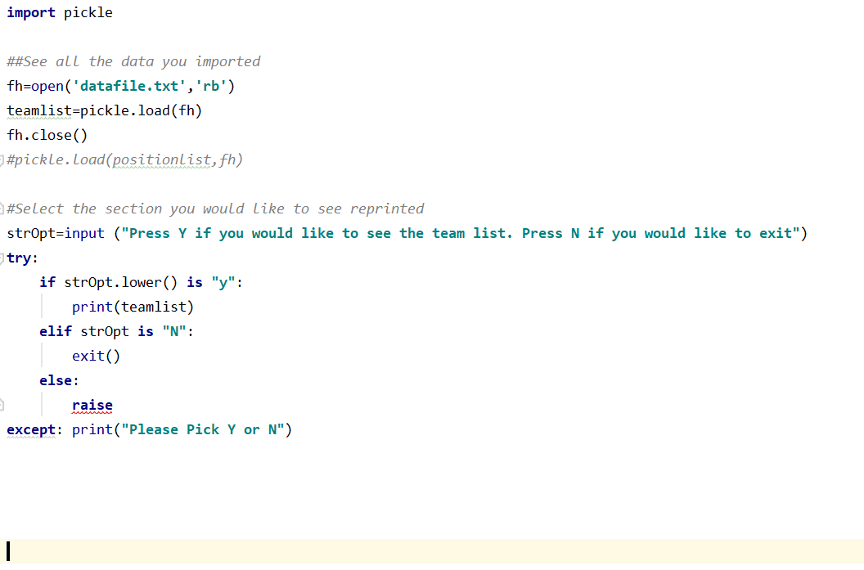

**Saving the Script:**  
I used the Pycharm console to create a new file called Assignment 7. I also updated the header of the script to provide useful information for someone reading it over.

**Summary:**

After watching the week’s lesson I read the seventh chapter of the textbook. I also spent some time looking at the referenced videos and other online materials. Using that knowledge I was able to put together a script that included a menu and a dictionary. I referred to [www.stackoverflow.com](http://www.stackoverflow.com) often for examples and discussion on how to put together both pickle and error control code. It was good to see the forums where people posted examples and then read the discussion of why things worked or didn’t.